Revised Project Plan

Electronic Informed Consent Management System

|  |  |
| --- | --- |
| Primary Instructor | Anjana Shah |
| Team Member | Natallia Isayenka |
| Team Member | Anna Poluektova |

Document Revision History

|  |  |
| --- | --- |
| Revision # | Date |
| 0.1 | 07-October-2014 |
| 0.2 | 16-January-2015 |

# Table of Contents

Table of Contents 2

1. Executive Summary 3

2. Project Approvers, Reviews and Distribution List 3

3. Scope 4

4. Deliverables 4

5. Assumptions 5

6. Dependencies 5

7. Risk Management 6

8. Communication 7

9. Task Listing 8

10. Milestones 10

11. Approval 11

Attachment 1. Tasks

Attachment 2. Gantt Chart. Version 1

Attachment 3. Gantt Chart. Version 2

# 1. Executive Summary

|  |  |
| --- | --- |
| Objective | The main objective is to build a web application that would implement all consent management workflows including obtaining consent and electronic signature, audit log and administrative interface for user management. |
| Corporate Goals Addressed | 1. Patient demographic information management; 2. Consent form management; 3. Fast and secure access to patient and consent information through search and reporting capabilities. |
| Planned Start Date | September 6, 2014 |
| Planned End Date | April 3, 2015 |

# 2. Project Approvers, Reviews and Distribution List

|  |  |  |  |
| --- | --- | --- | --- |
| Project Role | Name | E-mail | Date |
| Project Manager | Anjana Shah | ashah@georgebrown.ca | September 6, 2014 |
| Business Analyst | NI, AP | nisayenka@georgebrown.ca | September 6, 2014 |
| System Architect/Analyst | NI, AP | apoluektova@georgebrown.ca | September 6, 2014 |
| Software Developer | NI, AP | apoluektova@georgebrown.ca | September 6, 2014 |
| Quality Control/Quality Assurance Specialist | NI, AP | nisayenka@georgebrown.ca | September 6, 2014 |
| Project Sponsor | NI, AP | nisayenka@georgebrown.ca  apoluektova@georgebrown.ca | September 6, 2014 |

Team 1 - Natallia Isayenka (NI)

Team 2 - Anna Poluektova (AP)

# 3. Scope

|  |  |
| --- | --- |
| In Scope | Out of Scope |
| Patient management module | The system will not support integration with third party clinical trial management or electronic data capture software. |
| Consent form template management module |
| Informed Consent tracking module |
| Search and reporting capabilities |
| HTTP over SSL encryption |
| Password based authentication |
| Role based security |
| Audit log and tracking all changes in the database with capturing information of who made specific that change and when |

# 4. Deliverables

|  |  |
| --- | --- |
| Deliverable | Description |
| Software distribution package | Application package including with dependencies i.e. third party libraries and frameworks |
| Back end storage initial dump or scripts | Database dump with initially preloaded configuration data or set of schema generation and initial data loading scripts. Can be implemented as part of software distribution package. |
| Installation and Deployment Guide | Step by step instruction how to install and configure application |

# 5. Assumptions

System related assumptions:

* System would use responsive design methodology that allows using devices with different screen size and resolution such as mobile phones, tablets and desktop computers.
* System will analyze screen resolution and screen size and adjust page layout to make content shaped best for the device. For example, some second priority details might be removed from page when mobile phone is used.

System related assumptions:

* Due to responsive design support, client web browser must be HTML5 compatible.
* Users may use built-in host operation system accessibility features if necessary. Most of modern operations systems such as Windows 8, OS X, iOS and Android have build-in accessibility features, which are available through the browser such as Chrome, Safari or IE.
* There would not be any specially designed accessibility features in the application due to the time limitation.

# 6. Dependencies

Electronic Informed Consent Management System can manage internal dependencies. An internal dependency is illustrated by a web application project depending on another project that contains service classes, model objects, or persistence logic.

Internal dependencies are:

1. a compile dependency on the JavaScript library from jQuery. This type of dependency will be used in a project depended on this library for compilation, testing, and during execution.
2. a dependency on the RESTful or web-socket based web services. This dependency is used when needed to reference this library only during testing.

# 7. Risk Management

|  |  |  |  |
| --- | --- | --- | --- |
| Potential Risk | Severity (H/M/L) | Likelihood (H/M/L) | Management Strategy |
| Time | High | High | 1. Carry a schedule and record all thoughts and activities for a week.  2. Make an appointment book to schedule appointments.  3. Complete a time plan before starting a day. |
| Costs | High | High | 1. Determining your Value and Cost Drivers.  2. Strategic Cost Efficiency and Cost Analysis.  3. Cost Reduction - Review and Reduce Costs. |

# 8. Communication

**Reporting**

|  |  |  |
| --- | --- | --- |
| Report | Audience | Frequency |
| Progress and Status Report | Sponsor, Project Manager, Development Team | Weekly |

**Meetings**

|  |  |  |  |
| --- | --- | --- | --- |
| Meeting | Purpose | Attendees | Frequency |
| Daily team meeting | Agenda:   * Tasks assignments * Who is doing what reports from developers * Implementation and communication issues | * Development team * Project Manager | Daily |
| Weekly status meeting | Agenda:   * Progress report * Implementation and communication issues | * Project Manager * Project Sponsor | Weekly |

# 9. Task Listing

|  |  |  |  |
| --- | --- | --- | --- |
| Reference | Tasks | Duration (Days) | Dependency |
| A | Electronic Informed Consent Management System Project |  |  |
| B | **Define Problem** |  |  |
| C | Analyze requirements | 4 | NI |
| D | Initiate Development Process | 8 | AP |
| E | Compile Project Vision | 14 | NI |
| F | Preliminary Project Plan and Project  Suggestion | 15 | NI, AP |
| G | Project Plan Submission |  |  |
| H | **Analyze Situation** |  |  |
| I | Conduct Analysis Needs | 4 | NI |
| J | Prepare Functional Specification Document | 5 | AP |
| K | Construct Analysis Portfolio | 8 | AP |
| L | Analysis Review Data | 7 | NI |
| M | Review Hardware | 5 | NI, AP |
| N | Analysis Portfolio Submission |  |  |
| O | **Design Solution** |  |  |
| P | Construct Design Portfolio  Based On Functional Specifications | 10 | NI, AP |
| Q | Create Wireframes | 7 | NI |
| R | Design Review | 4 | AP |
| S | Revise Analysis/Design Documents | 4 | NI |
| T | Design Portfolio and Wireframes Submission |  |  |
| U | **Implement Design** |  |  |
| V | Setup Network and Software | 14 | NI, AP |
| W | Design Procedures, New Forms,  And Web Application | 15 | NI, AP |
| X | Perform Unit And Integration Tests | 12 | NI, AP |
| Y | Perform System and User Test | 16 | NI, AP |
| Z | Perform Full Test System | 13 | NI, AP |
| ZZ | Full Program Submission |  |  |

Team 1 - Natallia Isayenka (NI)

Team 2 - Anna Poluektova (AP)

Gantt Chart from the Task Listing (Attachment 1. Tasks, Attachment2. Gantt Chart. Version1, Attachment 3. Gantt Chart. Version 2)

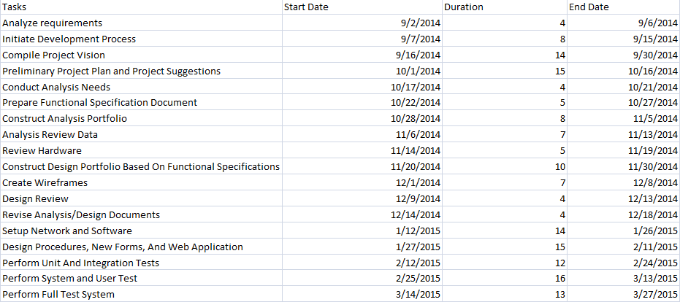

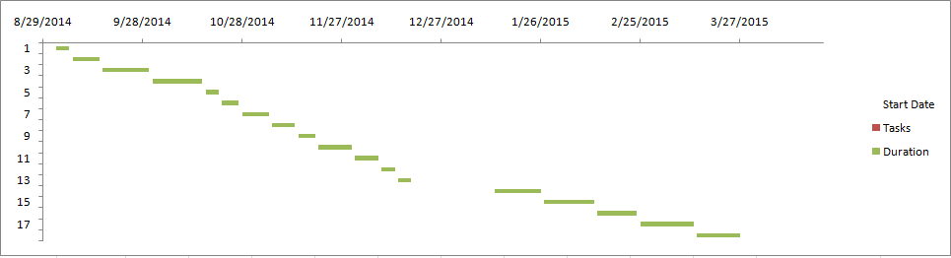

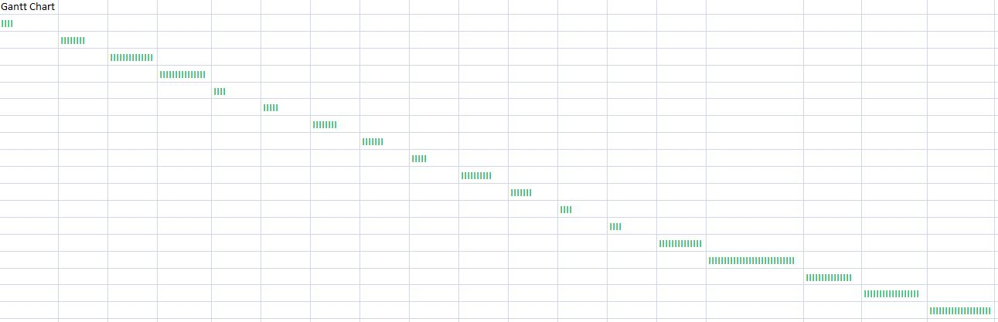

# 

# 10. Milestones

|  |  |  |
| --- | --- | --- |
| Major Activity or Milestone | Estimated Milestone Target date | Owner/Reviewer Team Members |
| Development environment setup(WebStorm, Firebug) | January 19, 2015 |  |
| Database setup and configuration (MongoDB) | January 19, 2015 |  |
| NodeJS setup and configuration (Express, bower, protractor, karma, moongose modules deployment and configuration) | January 19, 2015 |  |
| Static resources request/response controller implementation | January 19, 2015 |  |
| Server side default controller implementation | January 19, 2015 |  |
| Server side /patients controller implementation. Temporary loopback returns hardcoded JSON object collection for datagrid until interface to database is implemented. | January 19, 2015 |  |
| Bower client side dependency management integration implemented | January 19, 2015 |  |
| Full bootstrap support to be added to main page | February 2, 2015 |  |
| AngularJS integration to be added to main page | February 2, 2015 |  |
| Main tabs(patients, templates, consent) and main controller to be added to main page | February 2, 2015 |  |
| Angularjs-bootstrap integration to be implemented for main page | February 2, 2015 |  |
| Patients data UI grid to be added to patients tab | February 2, 2015 |  |
| Patient grid search to be implemented | February 2, 2015 |  |
| Redundant code and dependencies to be removed | February 2, 2015 |  |

# 11. Approval

|  |  |  |  |
| --- | --- | --- | --- |
| Project Role | Name | Signature | Date |
| Project Manager | Anjana Shah |  | September 6, 2014 |
| Business Analyst | NI, AP |  | September 6, 2014 |
| System Architect/Analyst | NI, AP |  | September 6, 2014 |
| Software Developer | NI, AP |  | September 6, 2014 |
| Quality Control/Quality Assurance Specialist | NI, AP |  | September 6, 2014 |

Team 1 - Natallia Isayenka (NI)

Team 2 - Anna Poluektova (AP)